
K4 CSF3133 REKA BENTUK ANTARA MUKA BERASASKAN WEB
LAB REPORT 6
SEMESTER 3

PREPARED FOR: ASSOC. PROF. TS. DR. WAN NURAL JAWAHIR
LAB ASSISTANT: MISS WAN FATIN

PREPARED BY: AKMA ASYIFA BINTI ZULKARNAIE
NO. MATRIC: S75186
SUBMISSION DATE: 7 December 2025

Lab Module 6: JavaScript
6.3 Basic Javascript
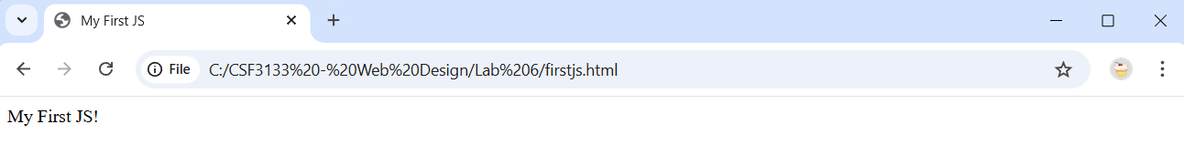
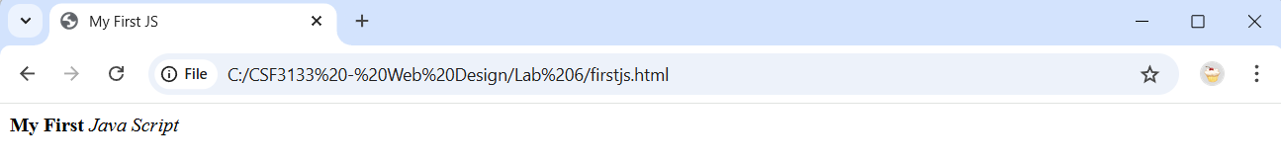

6.4 getElementById()
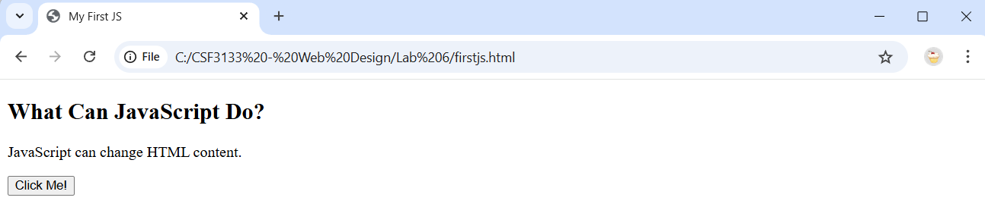

6.5 Date and Time
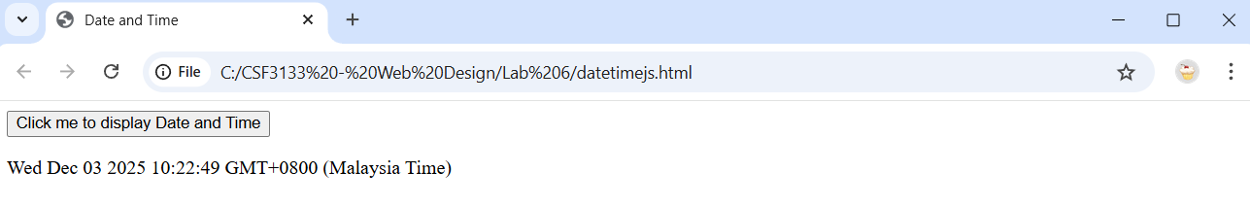
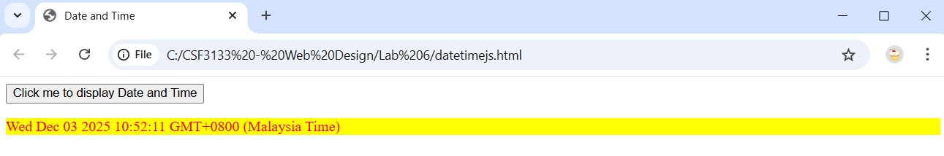

6.6 Change HTML Attributes Values
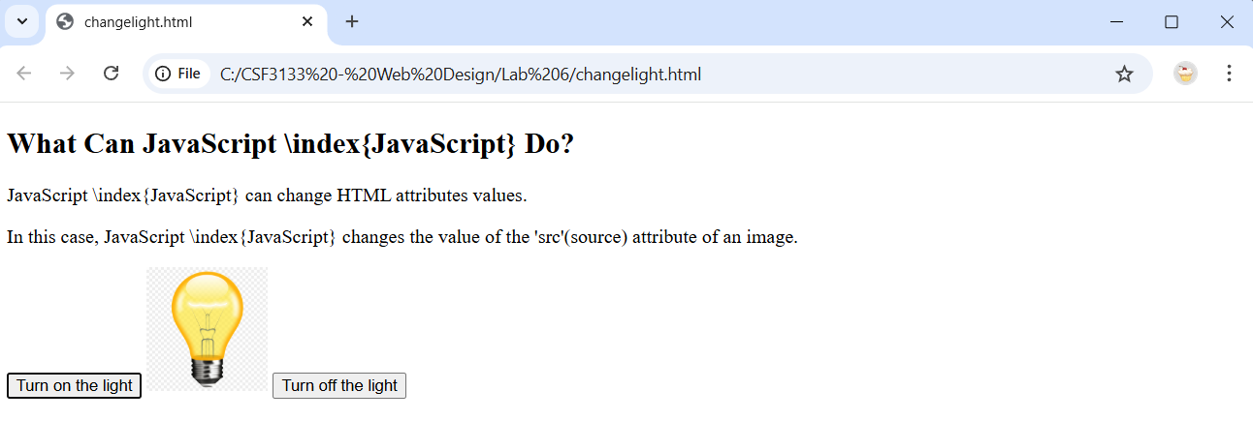
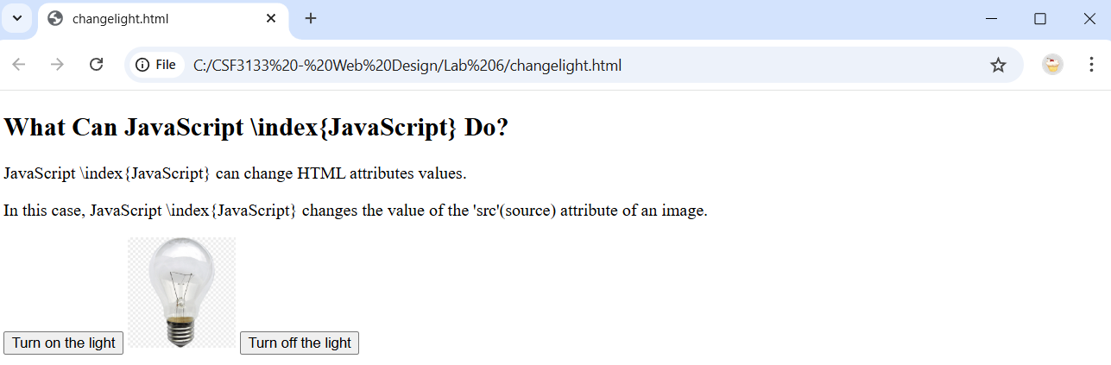

6.7.3 External References
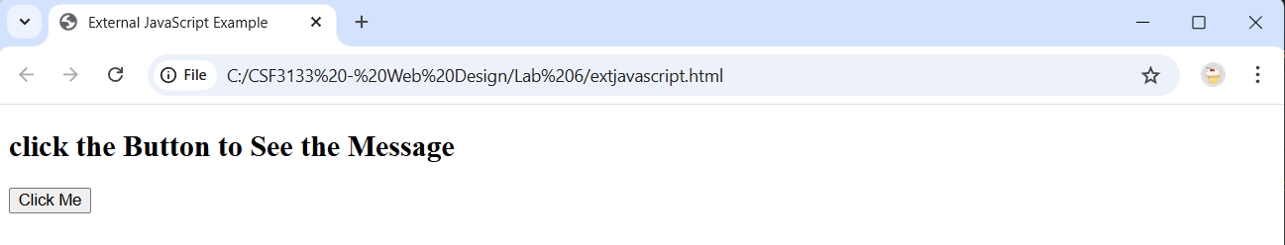
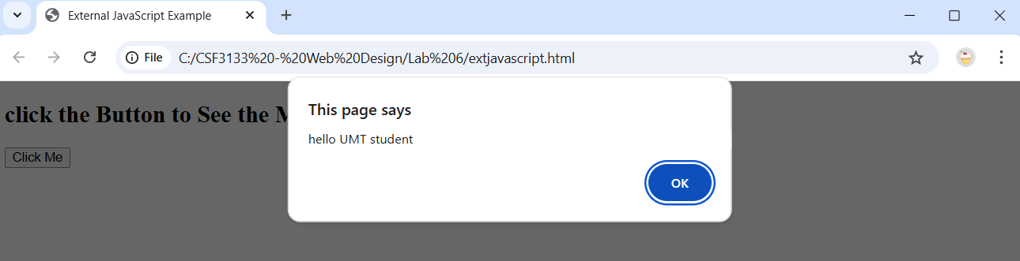

6.8 Working
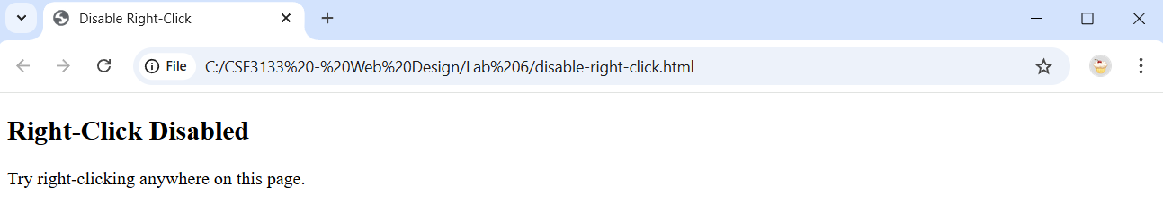
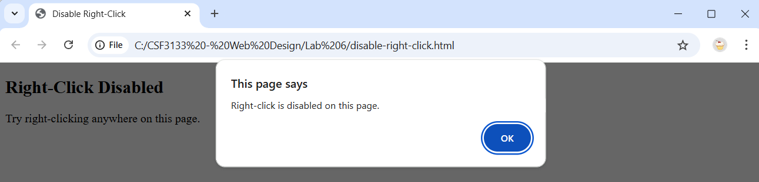

6.9 Multiplication Table
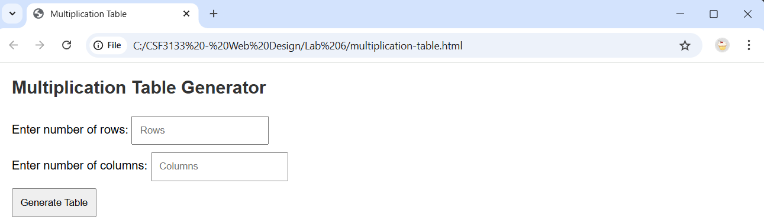
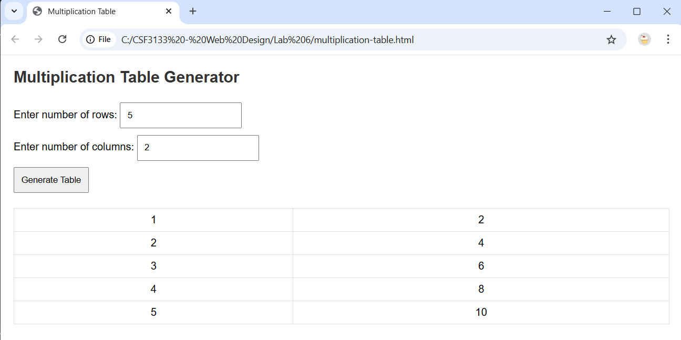
6.10 Client-side validation
6.10.1 Form Validation
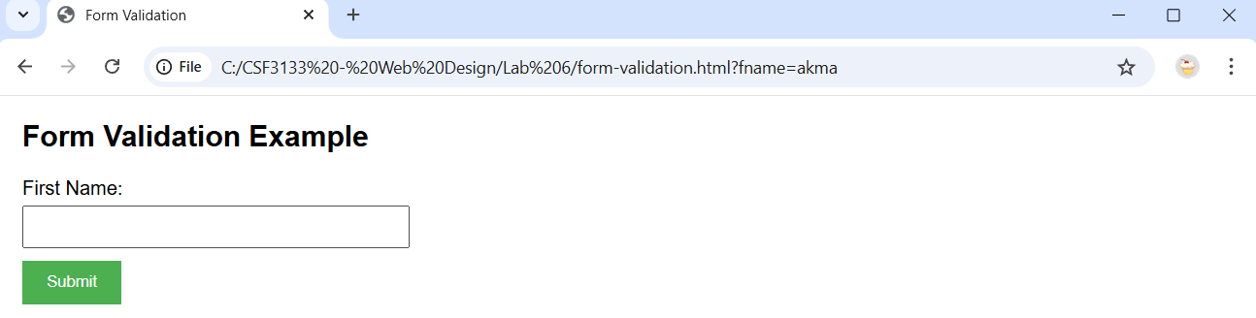
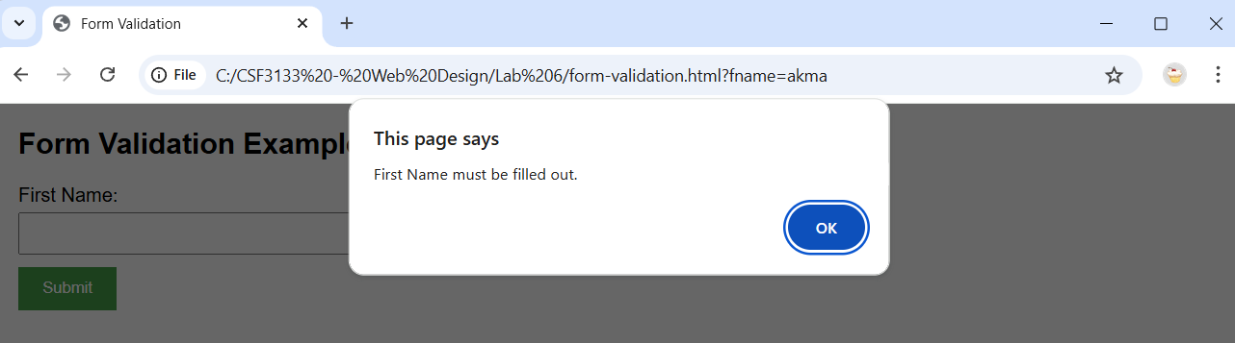
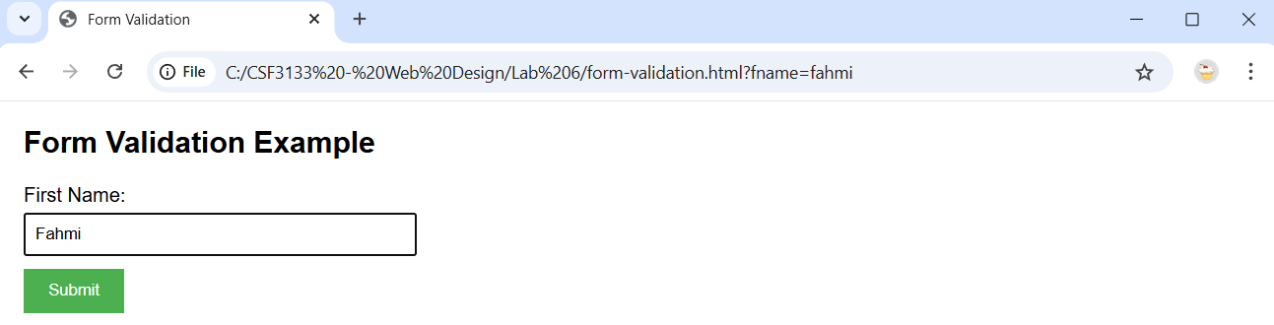
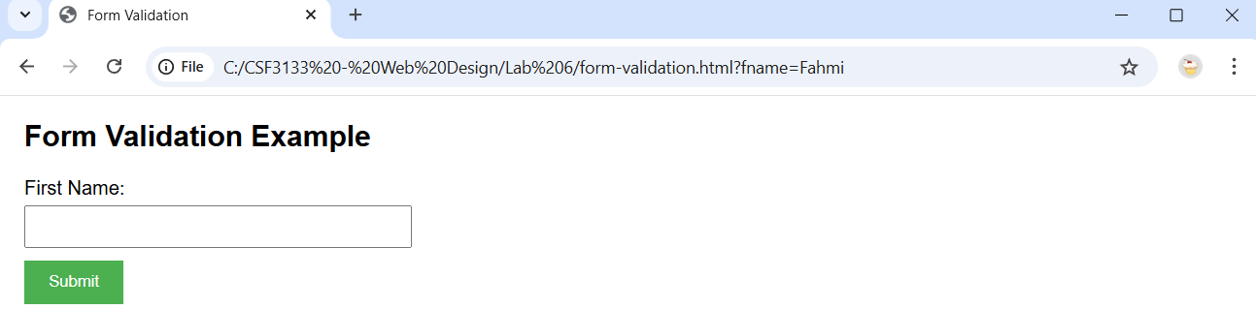

6.10.2 Numeric Input Validation
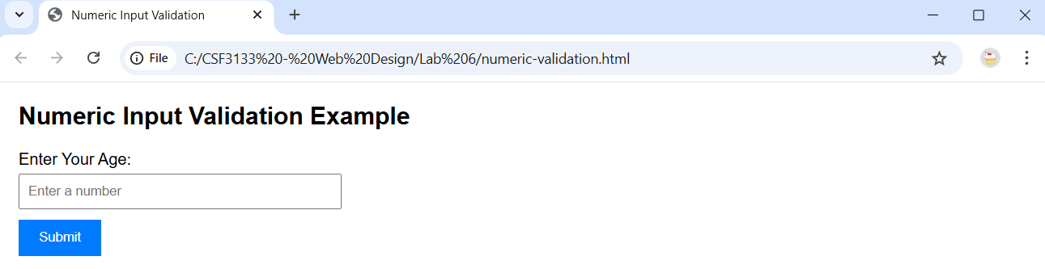
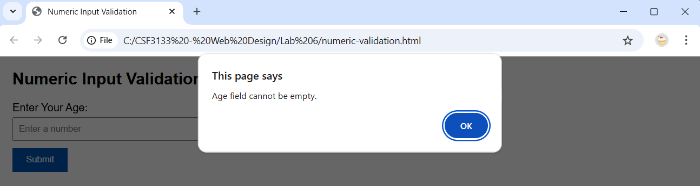
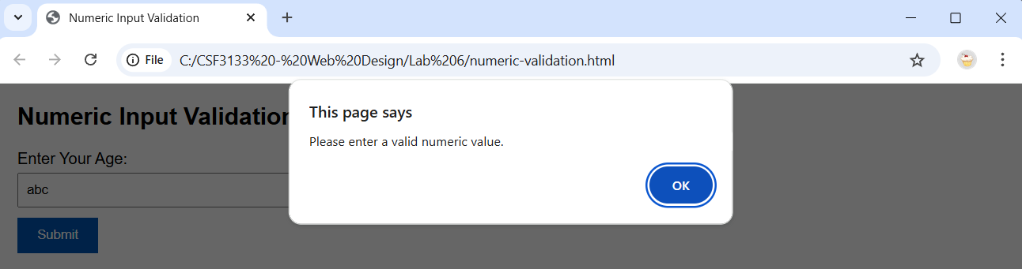
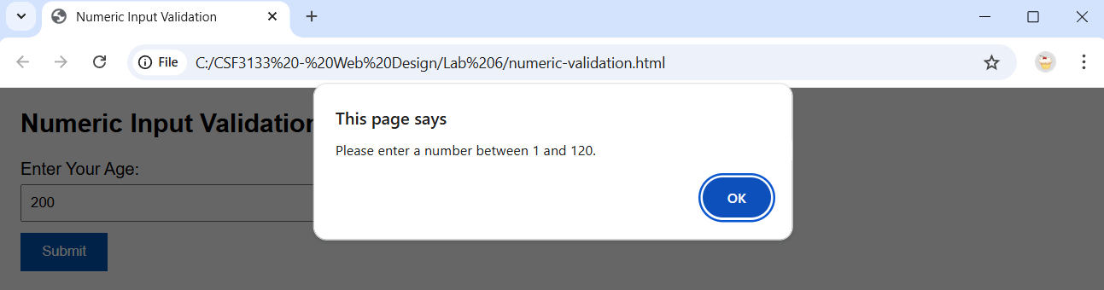
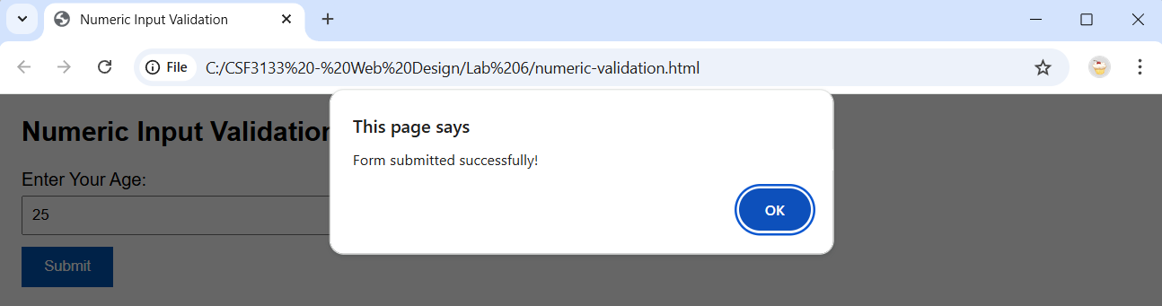

6.11 Math Function
6.11.1 Guess a Number
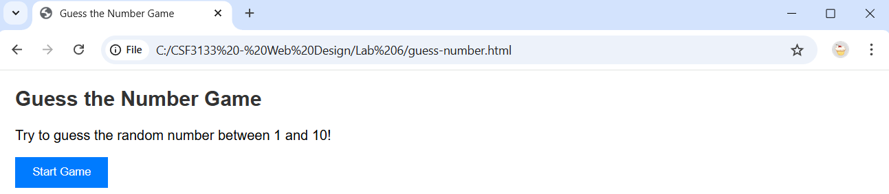
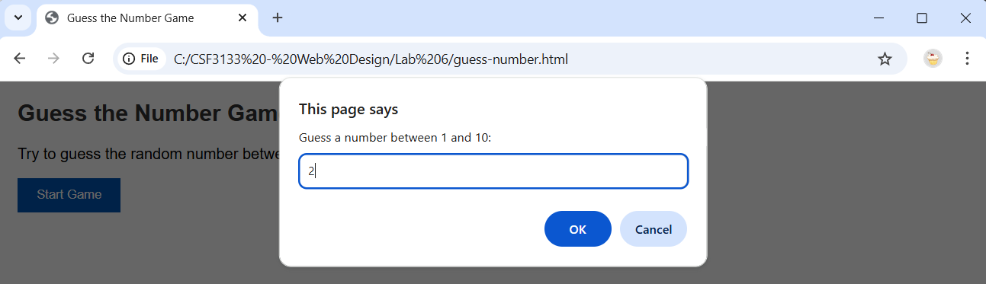
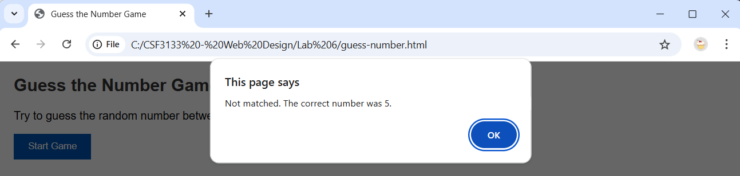

Lab Exercises
Index.html
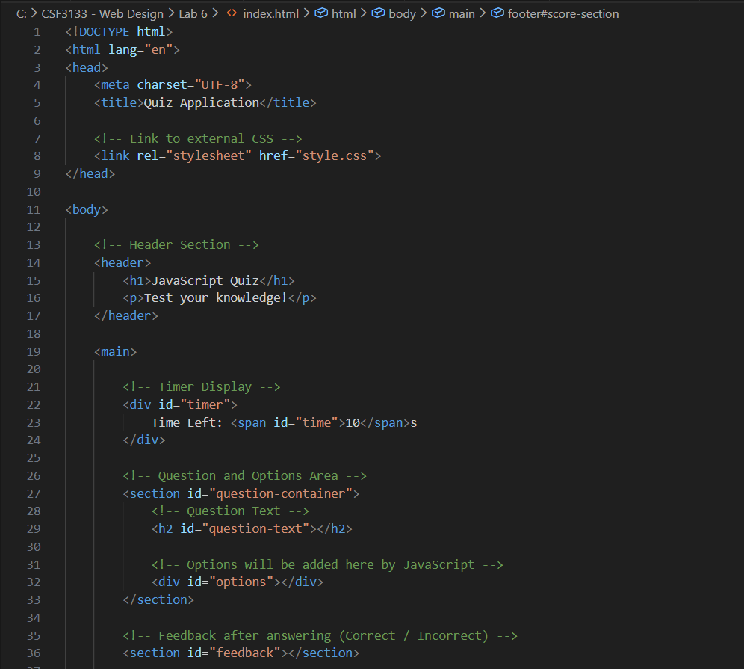
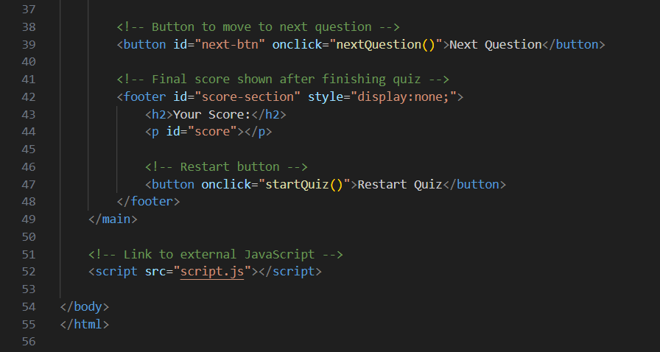

Style.css
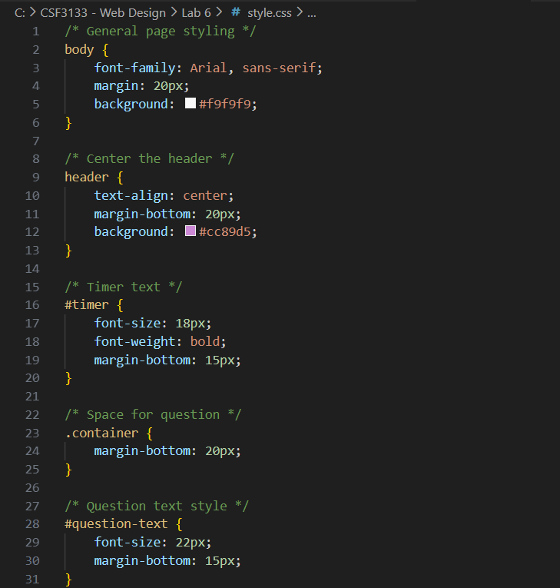
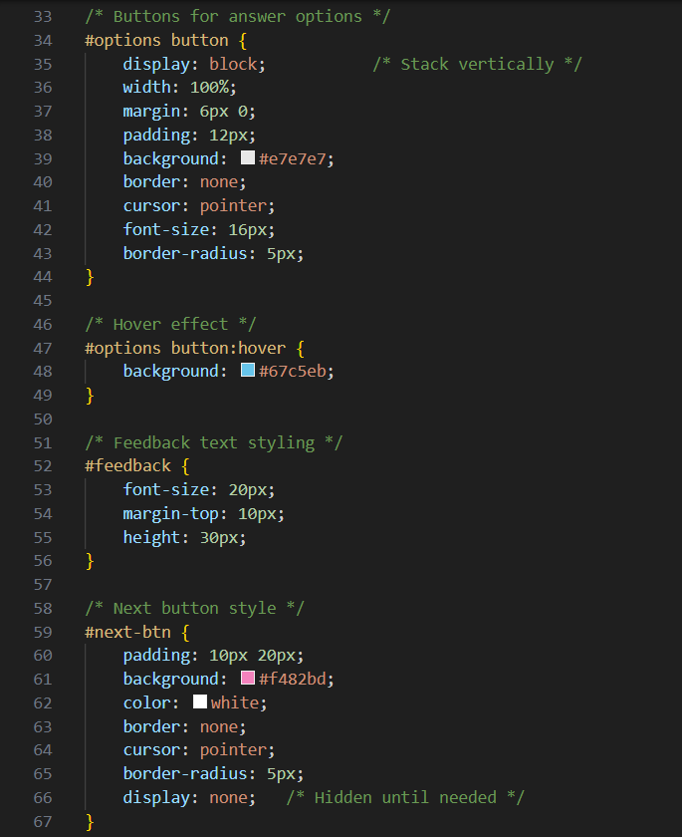

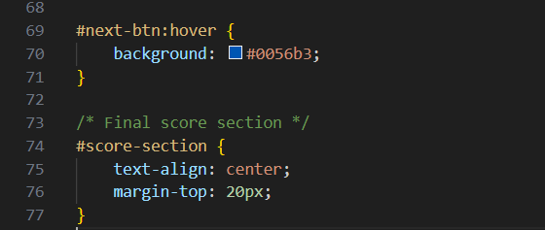

Script.js
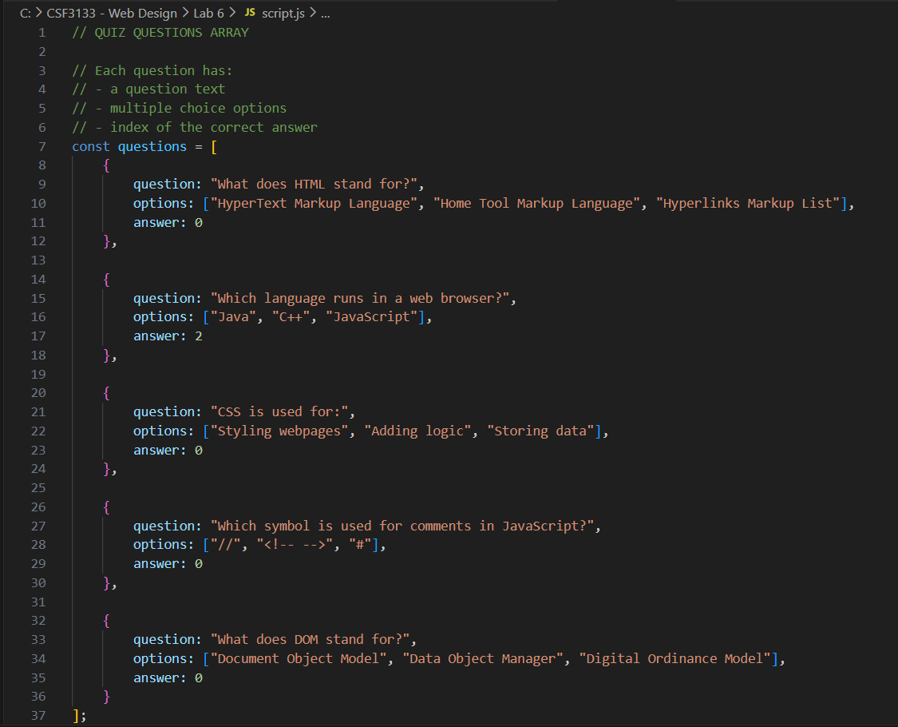
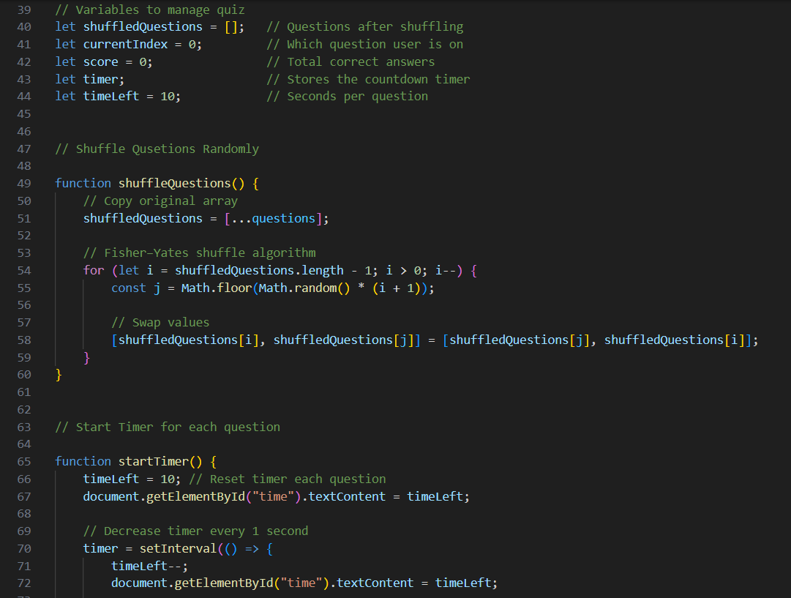

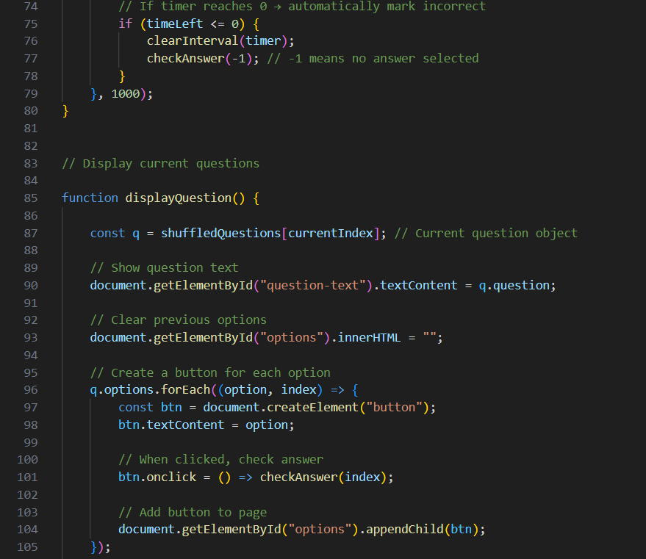
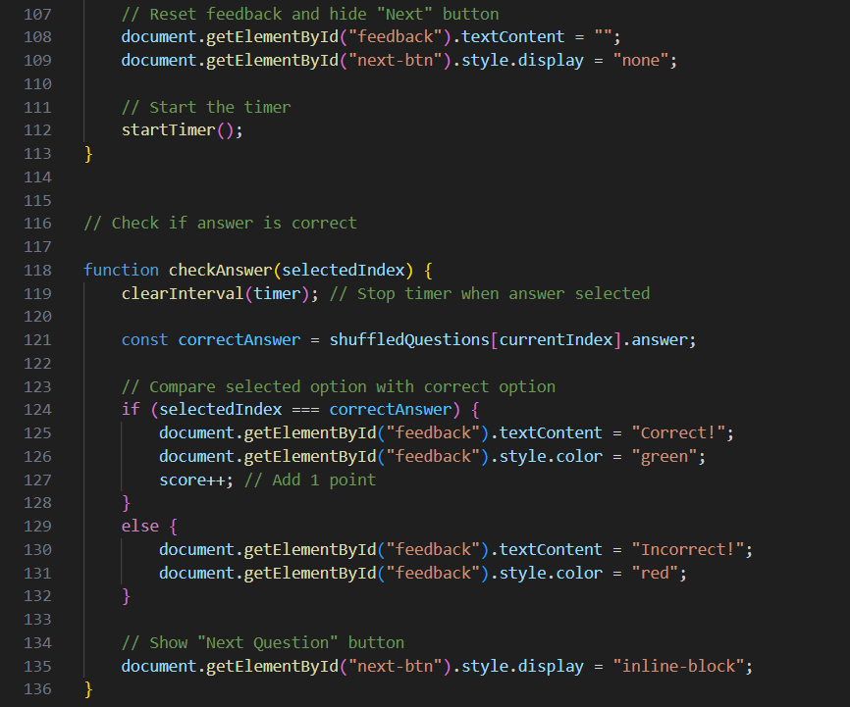
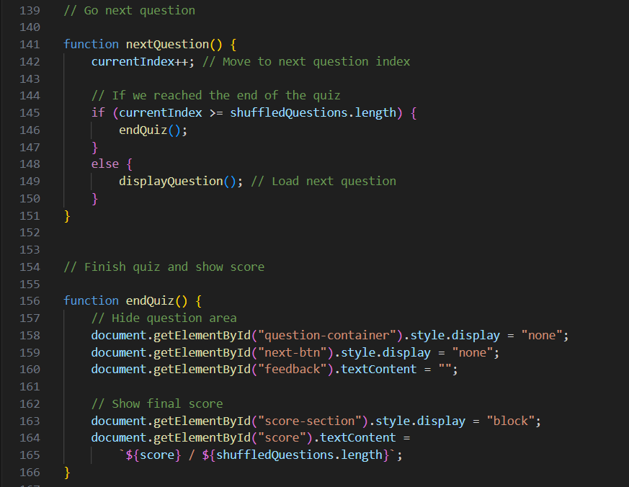
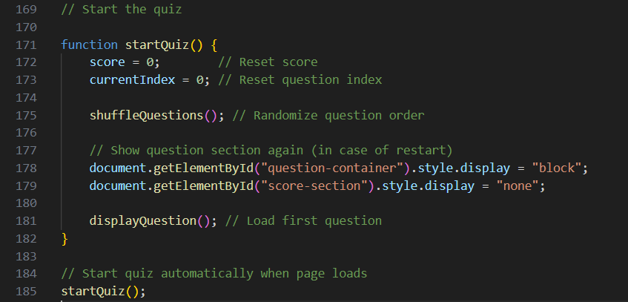

Output:
